**PHYSW3081_002_2017_1**

**Statistics of Counting with a Geiger Counter & Artificial Radioactivity**

**Prof. Elena Aprile**

**Date: May 27th, 2017**

**Author: Shah Faisal Mazhar**

**Partner: Ruben Rui Diaz-Pacheco**

**Abstract**

The objective of this experiment is to study the statistics of counting by using Geiger Muller Counter or GM tube in short and to study artificial radioactivity induced by slow neutron capture. While studying the statistics of counting, the GM tube plateau has been observed from the counting data of Cesium 137. The average counting rate vs voltage graph has given 954 volts as the suitable measuring voltage for the GM tube right after the plateau, although the latest lab manual suggested 950 volts. The background counting rate has been measured at 954 volts to find the background error of the GM tube and it is 0.26 Hz. The dead time of the GM tube 682.61 ± 160.87 µsec and it has been measured using *Rainwater and Wu*’s (1947) described method. Then, to study the Poisson’s distribution, counting data of Bismuth 207 has been collected and the mean is 1.32 ± 0.05 events. Also, to study the Gaussian distribution, the counting data of Cesium 137 has been collected and the mean is 28.34 ± 4.64 events. The average time interval distribution shows as same as the Poisson distribution, which is unexpected. Similarly, unexpected results have found while studying the artificial radioactivity. Irradiated Indium 116 has been used to collect counting data for an hour to calculate short and long lifetime and the values are respectively 4.05 sec and 90.90 sec. Although other results of this experiment are quite like the theoretical expectation described in *Knoll*’s book (2010) and *Rainwater and Wu*’s articles (1947).

**Introduction**

The GM tube is one of the oldest radiation detector and yet one of the most popular one because of its low cost and ease of operation. According to Knoll (2010), GM tube is the third kind of gas-filled detectors (Argon in this case) based on ionization. GM tube uses the gas multiplication of gas ionizing pair particles which later creates avalanches until both positive and negative charged particles respectively absorbed by anode and cathode. For GM tube, the cylindrical body works as the cathode and the central linear thick wire works as the anode.

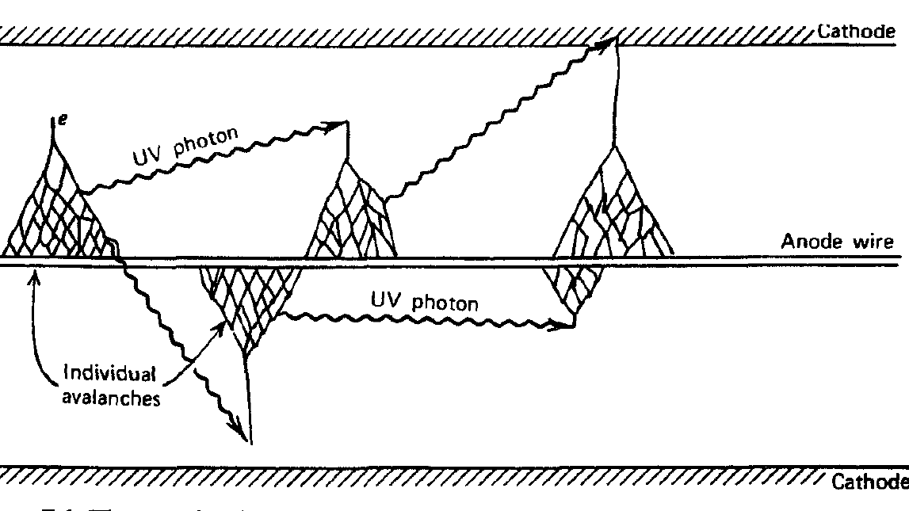

Figure 1: The mechanism of gas multiplication inside the GM tube. (Knoll, 2010)

When a radioactive material goes inside the GM tube, it makes the gas ionized. Such ionized gas creates a current (avalanche) between anode and cathode for a brief time. This current creates a voltage pulse. Each of the pulse is amplified and counted over time by an outside counter system. In this experiment, computer software (python coded program and an open source audio software) has been used as the counter.

An external suitable voltage is necessary to create the electric field inside the GM tube to get a constant count rate. Using the counting rate vs voltage graph or the GM tube plateau graph, the suitable voltage for the system can be found. It is also important to measure the background counting rate of the empty GM tube so that the error can be avoided from the results. Just taking the counting rate data of the empty GM tube in the suitable voltage gives the background counting rate, which is subtracted from all the results.

The background counting rate is one of the error that needs to be calculated and subtracted from the results. The background counting rate comes from the counting data obtained from the empty GM tube.

Background counting rate, B = $\frac{Event observed}{Total event}$ (Knoll, 2010) [Equation 1]

The GM tube also has a cool off time after an event of being insensitive to particles before taking the count of another event. This is called deadtime or insensitive time. *Rainwater and Wu*’s articles (1947) describes this issue and gives a method to calculate the dead time. According to them, three kinds of measurements need to be taken to calculate dead time: counting rate (n1) of source I with 50 to 1000 counts/sec or Hz, counting rate (n12) of both source I and source II where source II doubles the counting rate and counting rate (n2) of source II alone. If the total time of measurement is T, the dead time, τ can be calculated by the following equation,

τ = $\frac{n1+n2-n12 }{2*n1*n2}$ [Equation 2]

The uncertainty of the dead time, σ = $\frac{1}{n1*n2}$ $\sqrt{\frac{n12}{2T}}$* (*Rainwater and Wu*, 1947) [Equation 3]

The Poisson distribution is to study the events with the low probability of occurrence. To observe the Poisson distribution of radiation, the data needs to be taken from a source with low counting rate, around 2-4 Hz. On the other hand, the Gaussian distribution is to study the events with higher probability of occurrence. Any data distribution without rare probability can be studied through Gaussian distribution. In this experiment, a source with 100-1000 Hz has been used to study the Gaussian distribution of radiation. The average value of counts for both Poisson and Gaussian distribution is,

Average = $\frac{Total counts observed}{Total events}$ (*Rainwater and Wu*, 1947) [Equation 4]

Also, the time interval between the events can be calculated by finding the absolute difference of time between two consecutive events. These data can be used to create histogram to study the distribution of time interval.

Finally, to study the artificial radioactivity, a sample of irradiating Indium 116 has been used to study as it has both short lifetime (~14 sec) and long lifetime (~1 hour). The artificial radioactivity has been induced through slow neutron capture. After taking the data of Indium 116, the exponential decay equation along with mean life time equation has been used to calculate the short lifetime and the long lifetime. The exponential decay equation is,

N(t)= N0 * e – λ*t  (*Leo*, 1994) [Equation 5]

Mean lifetime, τ = $\frac{1}{λ}$ (*Leo*, 1994) [Equation 6]

It is extremely important to include uncertainty with every measurement. The uncertainty has been calculated through the following equation,

Uncertainty, σ = $\sqrt{\frac{Number of counts}{Total events}}$ (*Rainwater and Wu*, 1947) [Equation 7]

**Experimental Procedures**

The Set Up

The whole experimental set up contains three parts: the GM tube, the voltage controller and the computer. The sample has been inserted inside the GM tube to take the data. The voltage controller consists of a digital voltmeter to watch the voltage and the logic circuit with four switches along with a digitizer to find different voltages. Everything is interconnected with each other and finally with the computer. The computer works as the counter and the computer software: a python program and an open source audio software, has been used to collect the data for different number of events and times. The sources like Cesium and Indium has been provided along with the experimental set up, although Indium has been provided at the last day of data collection since it is highly radioactive and prohibited to the student to handle like other sources. 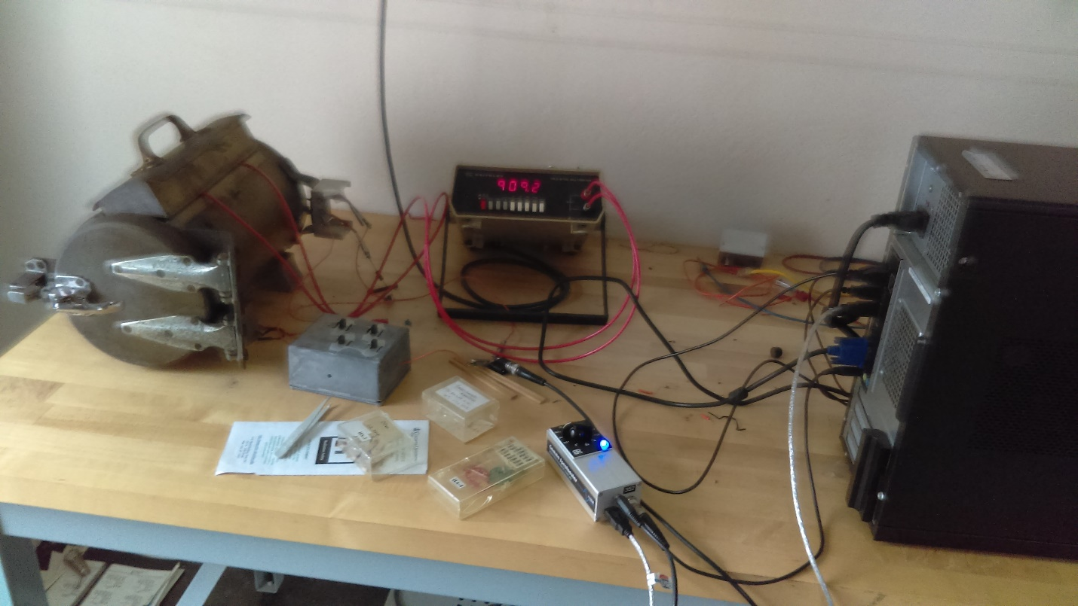

Figure 2: The GM tube (far left), the digital voltmeter (top middle), the logic circuit (right to the GM tube), the digitizer (bottom) and the CPU of the computer (far right).

Measuring the GM Tube Plateau

Although GM tube becomes more sensitive with higher voltage, it can be damaged if the voltage is more than 1000 volts. So, it is important to find the suitable higher voltage at which the counting rate changes barely along with the change of voltage. To find the appropriate voltage, Cesium 137 has been used as source and the counting rate data has been taken in different voltages. Data has been collected for 9 different voltage and around 10 events for each of the voltage with 5 seconds for each of the event. These data have been used to create the plateau graph and to find the suitable voltage of the GM tube.

Measuring the Background Counting Rate

After setting up the GM tube in the suitable voltage, the background counting rate data have been taken without inserting any source inside the GM tube. Only one 1000 seconds long event has been measured to get the background counting rate data.

Measuring the Dead Time

Only one 1000 seconds long event has been recorded for each step of dead time measurement. First, a Cesium 137 source has been inserted to get n1. Then, another Cesium 137 source has been inserted to measure n12 without moving the previous source, because, the second source must be with a counting rate that doubles the first counting rate (*Rainwater and Wu,* 1947). At last, the first source has been removed to measure only n2 of the second source.

Collecting Data to Construct the Poisson Distribution from the Small Counts

1000 events have been measured for Bismuth 207 where each event is 1 second long. Bismuth 207 has a low counting rate of 2-8 Hz which is appropriate to create the Poisson distribution.

Collecting Data to Construct the Gaussian Distribution from the Large Count

A 1000 events has been measured for Bismuth 207 where each event is 1.28 second long. Cesium 137 has a high counting rate of 40 Hz approximately which is suitable to create the Gaussian distribution.

Collecting Data to study Artificial Radioactivity by Neutron Irradiation

Irradiated Indium 116 has been used as the source to collect data. For the short life time, 9 events have been measured where each of them is 1 minute long. For the long life time, a one hour long event has been measured.

**Data and Analysis**

Raw Data

Because of the large amount of data, a sample data set of experimental part has been included in Appendix 1 at the end of this lab report. To create the graphs, python has been used and a sample python program has been included in Appendix 2.

Analysis on GM Tube Plateau

After collecting the data for different voltages, the counting rate of each of the event have been calculated and for each of the voltage, the average of the counting rate has been calculated.

|  |  |
| --- | --- |
| Event file number | Counts |
| 1 | 0 |
| 2 | 179 |
| 3 | 222 |
| 4 | 100 |
| 5 | 206 |
| 6 | 187 |
| 7 | 87 |
| 8 | 184 |
| 9 | 203 |
| 10 | 179 |
| 11 | 147 |
| 12 | 198 |
| Average number of Counts per event | 158.4167 |

Table 1: Sample calculation at 823 volts.

|  |  |  |
| --- | --- | --- |
| Voltage (V) | Average counts | Uncertainty |
| 605 | 0 | 0 |
| 648.5 | 0 | 0 |
| 692 | 0 | 0 |
| 735.5 | 0 | 0 |
| 779.5 | 0 | 0 |
| 823 | 158.42 | 12.59 |
| 867 | 199.25 | 14.12 |
| 910 | 213.75 | 14.62 |
| 954 | 209.46 | 14.47 |

Table 2: Voltage with average counts

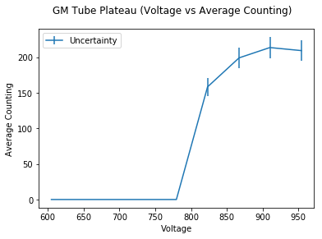

Figure 3: The graph of GM tube Plateau.

From figure 3, a constant counting can be observed after 910 volts. Since, the voltage cannot be more than 1000 volts, 954 volts is the highest suitable voltage from the GM tube plateau graph.

Analysis on the Background Counting Rate

After taking a 1000 sec event measurement, only 255 counts have been detected at 954 volts.

From equation 1, Background counting rate, B = $\frac{255}{1000}$ =0.26 Hz.

Uncertainty, σ = $\sqrt{0.255}$ Hz = 0.50 Hz

So, the background rate with the uncertainty is 0.26 ± 0.50 Hz.

Analysis on the Dead time

For the first source, 31189 counts have been recorded within 1000 seconds. For the both sources, 66115 counts have been recorded within 1000 seconds. Lastly, for the second source, 36726 counts have been recorded within 1000 seconds. From these data,

n1 = $\frac{31189}{1000}$ Hz = 31.19 Hz

n12 = $\frac{66115}{1000}$ Hz = 66.12 Hz

n2 = $\frac{36726}{1000}$ Hz = 36.73 Hz

After subtracting the background counting rate,

n1 = (31.19 - 0.26) Hz = 30.93 Hz

n12 = (66.12 - 0.26) Hz = 65.86 Hz

n2 = (36.73 – 0.26) Hz = 36.47 Hz

From equation 2, dead time, τ = $\frac{(30.93+36.47-65.86)}{2*30.93*36.47}$ sec = 682.61 µsec (micro second).

From equation 3, uncertainty, σ = $\frac{1}{30.93*36.47}$ $\sqrt{\frac{65.86}{2*(1000)}}$* sec = 160.87 µsec.

So, the dead time of the GM tube is 682.61 ± 160.87 µsec.

Analysis on the Poisson distribution of the small counts

After getting 1000 events, 500 events have been randomly chosen to record the counts and its frequency manually and used to graph the distribution.

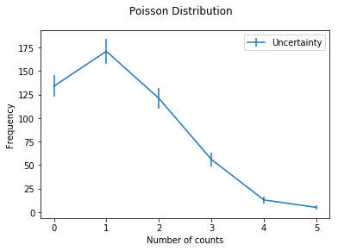

Figure 4: The Poisson distribution of low count.

The figure 4 looks like a Poisson distribution where most of the data at the lower counts. The mean of the distribution can be calculated by the method described by *Sullivan* (2014).

|  |  |  |  |
| --- | --- | --- | --- |
| Number of Counts | Frequency | Number of Counts*Frequency | Uncertainty |
| 0 | 134 | 0 | 11.58 |
| 1 | 171 | 171 | 13.08 |
| 2 | 121 | 242 | 11 |
| 3 | 56 | 168 | 7.48 |
| 4 | 13 | 52 | 3.61 |
| 5 | 5 | 25 | 2.24 |
| Total | 500 | 658 |  |

Table 3: The mean calculation with uncertainty.

The mean of the Poisson distribution (*Sullivan*, 2014)

= $\frac{Total Number of counts*Frequency}{Total Frequency}$ = $\frac{658}{500}$ = 1.32 events

Uncertainty (*Leo*, 1994), σ = $\sqrt{\frac{Mean}{Total event}}$ = $\sqrt{\frac{1.32}{500}}$ = 0.05 events

So, the mean of the Poisson distribution, λ = 1.32 ± 0.05 events, which is a low count.

Analysis on the Gaussian distribution of the large count

Out of 1000 events, 100 events have been randomly chosen and the counts are recoded manually to find the distribution of the large count.

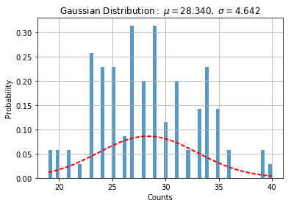

Figure 5: The Gaussian distribution of the large count.

From Figure 5, the mean of the distribution is 28.34 ± 4.64 events.

Analysis of Time Interval between the counts

The data from Cesium 137 Plateau measurement at 954 volts has been used to calculate the time interval between the events. First, two consecutive events have been subtracted from each other and the average of them has been taken to create the graph of the distribution.

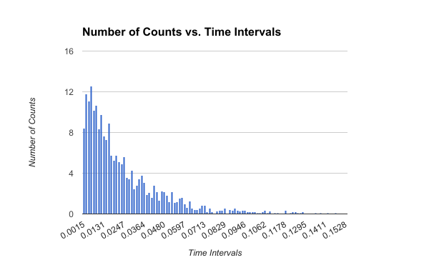

Figure 6: The Time Interval Distribution.

From Figure 6, the distribution seems like a Poisson distribution.

Analysis of Artificial Radioactivity

9 events with have been measured for irradiated Indium 116 where each of them 60 seconds long.

|  |  |  |
| --- | --- | --- |
| Event number | Number of Counts | Frequency |
| 1 | 59 | 0.9833 |
| 2 | 42 | 0.7 |
| 3 | 36 | 0.6 |
| 4 | 45 | 0.75 |
| 5 | 42 | 0.7 |
| 6 | 54 | 0.9 |
| 7 | 41 | 0.6833 |
| 8 | 46 | 0.7667 |
| 9 | 42 | 0.7 |

Table 4: Event data of Indium 116.

To measure the short life time, first three events has been considered and graphed. 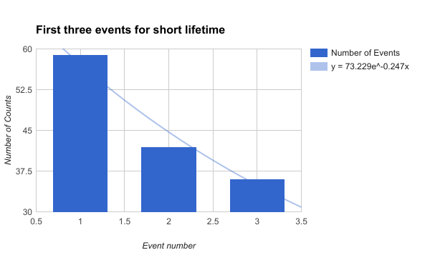

Figure 7: First three events to calculate the short lifetime.

After fitting the curve, the best fit equation is,

y = 73.23 * e-0.247x

Using equation 5 and 6, short lifetime = $\frac{1}{0.247}$ sec = 4.05 sec.

This is smaller than the expected short life time (~14sec)

By using the whole data distribution, the graph of long lifetime has been created.

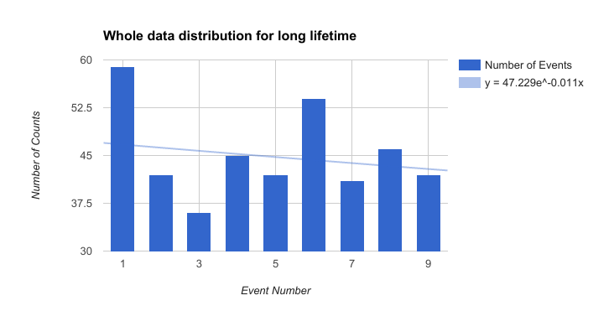

Figure 8: Data Distribution to Calculate the long lifetime.

After fitting the curve, the best fit equation is,

y = 47.229 * e-0.011x

Using equation 5 and 6, short lifetime = $\frac{1}{0.011}$ sec = 90.90 sec.

This is smaller than the expected long life time (~1 hour).

**Discussion**

A good amount of data with appropriate use of the theory has led to the expected calculation of the background counting rate and the dead time. Especially, the dead time is 682.61 µsec which is quite exact as mentioned in the lab manual (couple hundreds of microsecond). But, the lack of author’s experience with extracting and saving data from 1000 files has forced the author to use less amount of data to create the Poisson and the Gaussian distribution. Although both distributions show same results that can be expected from the theory, the distributions, especially the Gaussian distribution shows directly how the lack of data can affect the calculation. Same lack of data has been found while calculating the short and the long life time of Indium 116 which has given the calculated value much off from the expected value. The lack of data in this part has occurred because the python software was failing to take the data for an one hour measurement, although the audio software was getting the signals from the GM tube. After two failing attempts, the author and his partner were forced to take nine shorter measurements that has given such calculation.

Nevertheless, this experiment has given a valuable experience on the GM tube and the statistics of calculation. Without any doubt, the GM tube is one of the easiest radiation detector to work on. The author urges to change the code of the python program a bit so that it gives text file directly as output. Although the current output files can be open by the text editor, it creates problem to open in a analysis program and to extract data from it.

Works Cited

Knoll, Glenn F. *Radiation Detection and Measurement*. Hoboken, NJ: John Wiley & Sons, 2010. Print.

Leo, William R. *Techniques for Nuclear and Particle Physics Experiments: A How to Approach*. Berlin: Springer-Verlag, 1994. Print.

Rainwater, L. J., and C. S. Wu. "Applications of Probability Theory to Nuclear Particle Detection." N.p., 1947. Web. 26 Apr. 2017. <http://www.phys.columbia.edu/~w3081/EKA_Org.html>.

Sullivan, Michael, III. *Fundamental of Statistics*. 4th ed. Boston: Pearson, 2014. Print.

**Appendix 1**

Sample data file

1.897698769566855015e+00

2.618886040880489041e+00

9.254498959722599949e+00

9.484430884891992264e+00

1.090587776364895589e+01

1.393183183473555431e+01

2.131754942594419333e+01

2.257246022030156851e+01

2.257293688075848337e+01

2.936151241003658185e+01

2.938166833792902111e+01

4.271976282828343585e+01

4.419123635689956586e+01

4.533181673594812366e+01

4.644713411078015497e+01

5.169303211842569823e+01

5.169568779811422843e+01

5.169639143974110596e+01

5.170349595036085333e+01

5.170599274323041072e+01

5.174226433419000415e+01

5.180123404214558747e+01

5.180656809963964804e+01

5.181939253574238080e+01

5.182588419720323714e+01

5.182985636767753590e+01

5.183187650009018199e+01

5.183280712288701864e+01

5.448996218902274791e+01

5.789865190889575075e+01

6.750456311595029035e+01

6.974693279210126207e+01

7.008992403802768933e+01

**Appendix 2**

Sample python coding to create graph

from scipy.stats import norm

import matplotlib.mlab as mlab

import matplotlib.pyplot as plt

# read data from a text file. One number per line

arch = "Gaussian.txt"

datos = []

for item in open(arch,'r'):

item = item.strip()

if item != '':

try:

datos.append(float(item))

except ValueError:

pass

# best fit of data

(mu, sigma) = norm.fit(datos)

# the histogram of the data

n, bins, patches = plt.hist(datos, 60, normed=1, alpha=0.75)

# add a 'best fit' line

y = mlab.normpdf( bins, mu, sigma)

l = plt.plot(bins, y, 'r--', linewidth=2)

#plot

plt.xlabel("Counts")

plt.ylabel('Probability')

plt.title(r'$\mathrm{Gaussian\ Distribution:}\ \mu=%.3f,\ \sigma=%.3f$' %(mu, sigma))

plt.grid(True)

plt.show()

plt.savefig('Gau.png')